CROSS REGION REPLICATION

The AWS S3 - Cross-region replication (CRR) allows you to replicate or copy your data in two different regions.

1. **Improving latency and enhancing availability:** If you are running a big organization with customers all around the world then making objects available to them with low latency is of great importance. By setting up cross-region replication you can enable your customers to get objects from S3 buckets which are nearest to their geographic location.
2. **Disaster recovery:** Having your data in more than one region will help you prepare and handle data loss due to some unprecedented circumstances.
3. **To meet compliance requirements:** Sometimes just to meet compliance requirements you will need to have a copy of your data in more than one region and cross-region replication can help you achieve that.
4. **Owner override:** With AWS S3 object replication in place you can maintain the same copy of data under different ownership. You can change the ownership to the owner of the AWS destination bucket even if the source bucket is owned by someone else.

**Lab Steps:**

Task 1: Sign in to AWS Management Console

1. Click on the Open Console button, and you will get redirected to AWS Console in a new browser tab.

2. On the AWS sign-in page,

· Leave the Account ID as default

·Now enter your username and password.

3. click on sign-in.

4.After signing in select US East (N. Virginia) us-east- as AWS region.

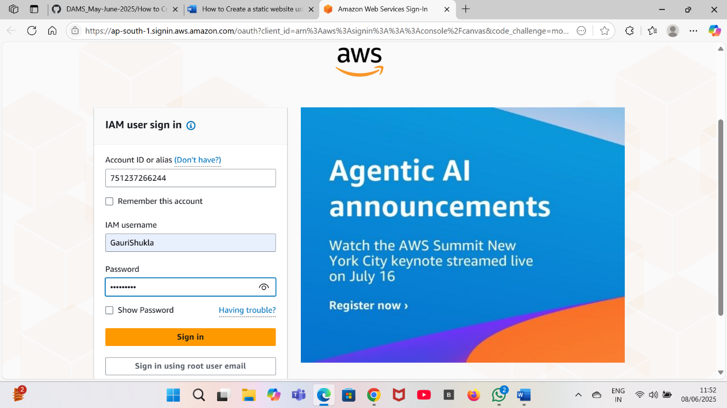

**Task 2: Creating an S3 Source Bucket:**

1. Select region as US East (N.Virginia) us-east-1.
2. Click on search bar and enter S3 and then click on S3.
3. On the left side click on buckets and then click on create bucket.
4. Enter the details:

Bucket name: Enter source bucket name.

Region: Select US East (N. Virginia) us-east-1.

Object ownership: Select ACLs disabled.

Bucket settings for Block Public Access, Uncheck the option of Block all public access.

And, Acknowledge the same by checking the below option.

Bucket versioning: Select Enable.

1. Keep all other options as default.
2. Now click on create bucket.
3. Source Bucket is created now.

Task 3: Creating an S3 Target Bucket

1. On the left side click on buckets and then click on create bucket.
2. Enter the details:

Bucket name: Enter target bucket name.

Region: Select Asia Pacific (Mumbai) ap-south-1

Object ownership: Select ACLs disabled.

Bucket settings for Block Public Access, Uncheck the option of Block all public access.

And, Acknowledge the same by checking the below option.

Bucket versioning: Select Enable.

1. Keep all other options as default.
2. Now click on create bucket.
3. Target Bucket is created now.



Task 3: Setting Replication Rules

1. Click on the source bucket which you’ve created earlier.
2. Now click on Management, now scroll down to Replication rules.
3. Now, click on create Replication rules.
4. Enter details:
5. Replication rule name: Enter replication rule name.
6. Status: Enable.
7. Choose a rule scope : Select Apply to all objects in the bucket.
8. Destination: Select Choose a bucket in this account and click on browse S3.
9. Select the target bucket created earlier and click on Choose path button.
10. Under IAM Role, Select Choose from existing IAM roles and select Create new role.
11. e Destination Storage Class, select Change the storage class for the replicated objects and choose One Zone-I.
12. Leave everything as default.
13. . Review once and click on Save button. One Pop-up appears Select No, do not replicate existing objects.
14. Click on Submit button.

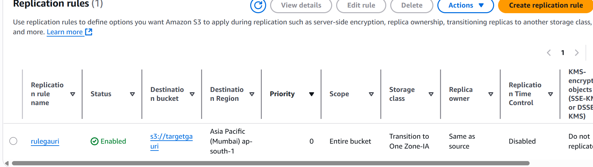

1. Go to the source bucket and upload an Object in the Source bucket by clicking on Add Files. Click on Upload.
2. . Click on the Add files button and upload any object from your local machine and click on Upload button.

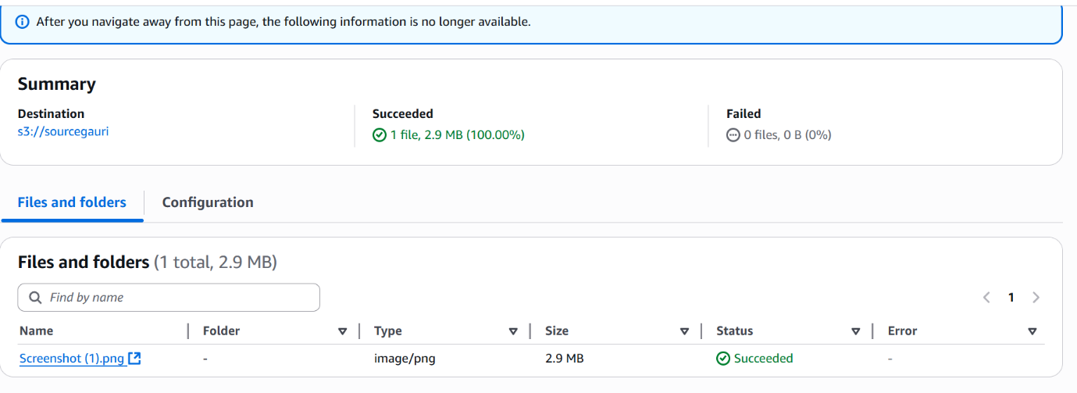

1. Go to your Target Bucket to see the replication.

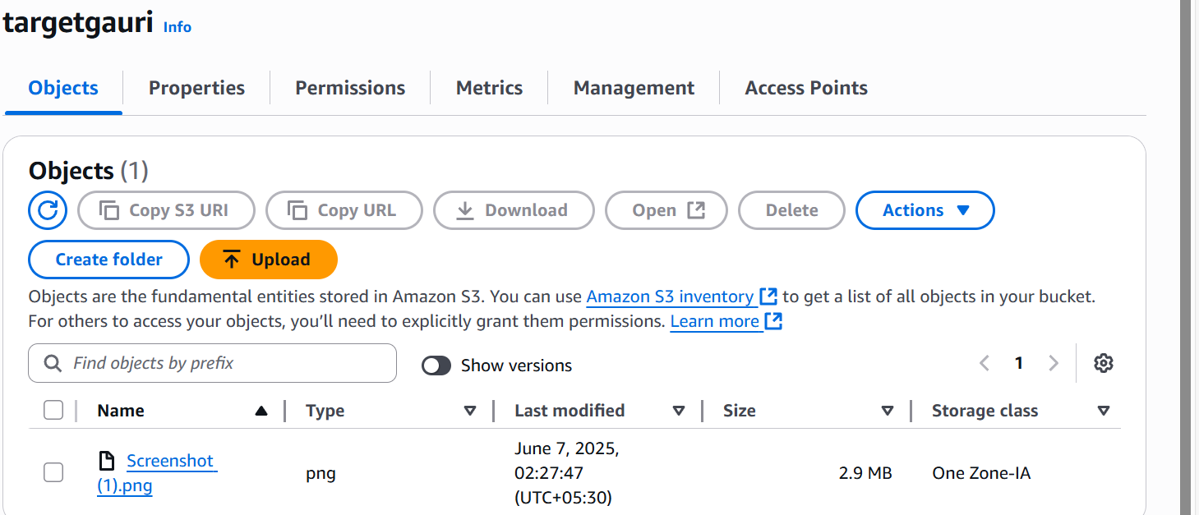

1. Now you have successfully configured the Cross-Region Replication in S3 Bucket.

**INTERVIEW QUESTIONS RELATED TO CROSS-REGION REPLICATION**

**1. What are the storage classes available in S3?**

**Answer:**

1. **S3 Standard:** High availability and performance for frequently accessed data.
2. **S3 Intelligent-Tiering:** Automatically moves data between access tiers based on usage.
3. **S3 Standard-IA:** Low-cost storage for infrequently accessed data.
4. **S3 One Zone-IA:** Similar to Standard-IA but stores data in a single availability zone.
5. **S3 Glacier:** Low-cost storage for archival with retrieval times ranging from minutes to hours.
6. **S3 Glacier Deep Archive:** Cheapest storage option, designed for long-term archival with retrieval times of up to 12 hours.

**2. What is S3 Versioning?**

**Answer:**  
S3 Versioning allows users to maintain multiple versions of an object in the same bucket.

* Helps to retrieve and restore previous versions of objects.
* Protects against accidental deletions or overwrites.

**3. What are S3 Bucket Policies and ACLs?**

**Answer:**

* **Bucket Policies:** JSON-based permissions applied to the bucket and objects within. They support fine-grained control.
* **Access Control Lists (ACLs):** Legacy mechanism for granting permissions at the bucket or object level.

**4. What is Cross-Region Replication (CRR) in S3?**

**Answer:**  
**Cross-Region Replication (CRR)** is a feature that automatically replicates objects from a bucket in one AWS region to a bucket in another region.

**Key Features:**

* Maintains copies of objects across different AWS regions.
* Ensures data durability and compliance (e.g., meeting disaster recovery or legal requirements).
* Works at the bucket or prefix level.

**Requirements:**

* Versioning must be enabled on both the source and destination buckets.
* Permissions must allow the source bucket to replicate data to the destination bucket.

**Benefits:**

1. **Disaster Recovery:** Ensures data is available even if one region becomes unavailable.
2. **Compliance:** Meets regulatory requirements for data residency or redundancy.
3. **Performance:** Improves data access latency for globally distributed users.

**Setting Up CRR:**

1. Enable versioning on both source and destination buckets.
2. Create a replication rule in the S3 bucket’s management console.

**Cost Considerations:**

* Data transfer charges apply for replication between regions.